TRADEMARK STABLES

PRIZE LIST

NCHJA “C” Shows

8:30am

2018 Show Dates Judge

Sept. 15/16 Loren Kirk

Steward

Sheri Bridges

Judge

Oct. 6 / 7 AC Jones

Steward

Tom Bennett

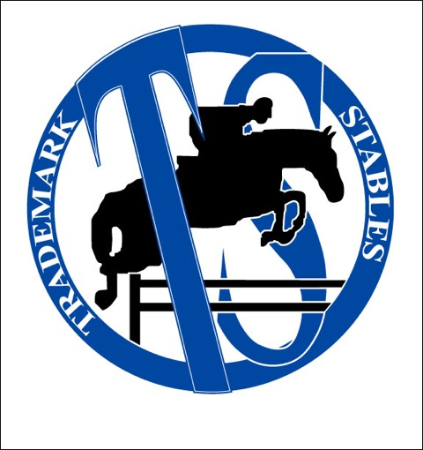

The horse show reserves the right to reschedule, combine, or delete any classes or to change the officials as needed. All entries are made at the owner’s, rider’s, trainer’s own risk. Neither Trademark Stables, LLC. Nor the management will be responsible in any way for the loss, damage, or accidents to horses, ponies, riders, spectators, equipment or vehicles brought to the show grounds. Overnight boarding is available. Contact Jennifer Bryant for more information

**(919) 349-1533**

[www.trademarkstables.com](http://www.trademarkstables.com)

[jbtrademarkstables@yahoo.com](mailto:jbtrademarkstables@yahoo.com)

2437 Olive Chapel Road

Apex, NC 27502

Directions:

From Raleigh: Hwy 64 west, turn on Kelly Rd. Next traffic light turn right on Olive Chapel Rd. Turn left into 2437 Olive Chapel Rd. Stay to the right as you come down the drive.



4441 Six Forks Road, Suite 106

Raleigh NC 27609

info@nchja.com | 919-538-4781

Renewal_________New Member_________

Name_______________________________

Address_____________________________

City,State,Zip_________________________

Phone_______________________________

Email_______________________________

Senior:_______ - if senior, please check one:

Professional_________ Amateur__________

If amateur, please indicate age group:

18-35_______ 36-45_______ 46+________

Junior:___________ - if junior, MUST have BIRTHDATE_________________________

I hereby apply for membership for the

year 20______ and enclose payment of

$_________Dues.

Seniors: $40.00

Juniors: $30.00

Farm: $50.00

Life: $350.00

V

**LUNCH BREAK  
(Outdoor ring open for schooling)**

29. Sm/Med Pony Hunter (2’3”)

30. Sm/Med Pony Hunter (2’3”)

31. Sm/Med Pony Hunter (U/S)

32. Large Pony Hunter (2’9”)

33. Large Pony Hunter (2’9”)

34. Large Pony Hunter (U/S)

35. NCHJA Pony Medal

41. Low Child Hunter (2’6”)

42. Low Child Hunter (2’6”)

43. Low Child Equitation (O/F)

44. Low Child Hunter (U/S)

45. Low Child Equitation (Flat)

46. Low Adult Hunter (2’6”)

47. Low Adult Hunter (2’6”)

48. Low Adult Equitation (O/F)

49. Low Adult Hunter (U/S)

50. Low Adult Equitation (Flat)

17. Short Stirrup Hunter (2’)

18. Short Stirrup Hunter (2’)

19. Short Stirrup Equitation (O/F)

20. Short Stirrup Hunter (U/S)

21. Short Stirrup Equitation (Flat)

22. Long Stirrup Hunter (2’)

23. Long Stirrup Hunter (2’)

24. Long Stirrup Equitation (O/F)

25. Long Stirrup Hunter (U/S)

26. Long Stirrup Equitation (Flat)

27. 11 & Under Equitation (Flat)

28. 11 & Under Equitation (2’- 2’3”)

55. Junior/Amateur Hunter (3’-3’3”)

56. Junior/Amateur Hunter (3’-3’3”)

57. Junior Amateur Hunter (U/S)

58. Wedgewood’s Surprise Memorial

Hunter Classic (respective heights)

**8:30am OUTDOOR RING**

1. Walk/Trot Pleasure

2. Walk/Trot U/S

3. Walk/Trot Equitation

4. Young Entry Warm Up

5. Young Entry Hunter (O/F)

6. Young Entry Hunter (O/F)

7. Young Entry Equitation (O/F)

8. Young Entry Hunter (U/S)

9. Young Entry Equitation (Flat)

LeadLine

10. WarmUp (all day)

38. Schooling Hunter (2’3”-2’6”)

39. Schooling Hunter (2’3”-2’6”)

40. Schooling Hunter (U/S)

36. 12-14 Equitation (Flat)

37. 12-14 Equitation (O/F) (2’3”- 2’6”)

11. 15-17 Equitation (Flat)

12. 15-17 Equitation (O/F) (2’6”-2’9’)

13. Children’s Hunter (2’9”)

14. Children’s Hunter (2’9”)

15. Children’s Hunter (U/S)

16. NCHJA Children’s Equitation Medal

51. Adult Amateur Hunter (2’9”)

52. Adult Amateur Hunter (2’9”)

53. Adult Amateur Hunter (U/S)

54. NCHJA Adult Equitation Medal

**Young Entry** is open to junior riders in their first 2 years of showing.

**Long Stirrup** is open to riders over 12 years of age.

**Walk/Trot** is open to riders in their first year of showing.

**Short Stirrup Hunter, Long Stirrup, Pony Hunter, Low Child/Low Adult Hunter, Children’s Hunter, Adultus Amateur Hunter, Junior/Amateur Hunter, Age-group Equitation and NCHJA Equitation Medals** are run in accordance to the **NCHJA rules.**

**Schooling Hunter and Warm-Ups** are open to all horses and riders.

**Trademark Stables Year-End Awards** are awarded in all divisions. You must show at a minimum of **3** shows during the year and be present at the year end show to receive awards.

**Approved ASTM/SEI hard hats must be worn** by all riders, with properly fastened chin strap, when mounted on any horse or pony.

**Entry Fees:**

All Classes: $15 per class

Stalls: $25

Service Fee $25