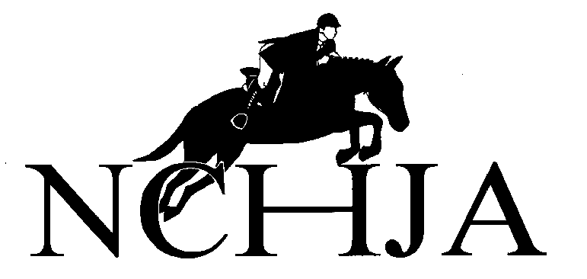
Annual Meeting and Awards Banquet Registration Form
January 16, 2026 – Pinehurst Resort
Please mail or email this form to the address below. All reservations must be received no later than January 2, 2026. We will not be able to seat people without an advance reservation.

Judge’s Clinic: The NCHJA requires licensed officials to complete a clinic every three years as part of their continuing education.

Number of Licensed Officials: ______ @ $30.00 = $________
Number of Members to Audit: ______ @ $10.00 = $________
Number of Non-Members to Audit: ______ @ $20.00 = $________

Steward’s Clinic: The NCHJA requires licensed officials to complete a clinic every three years as part of their continuing education.

Number of Licensed Officials: ______ @ No Charge
Number of Members to Audit: ______ @ No Charge
Number of Non-Members to Audit: ______ @ No Charge

Junior Luncheon: There will be a keynote speaker and Junior Information at the Junior Luncheon.

Numbers of Juniors: ______ @ $30.00 = $________

Awards Banquet:
Numbers of Adult Attendees: ______ @ $125.00 = $________
Numbers of Junior Attendees: ______ @ $100.00 = $________

2026 Horse Show Sponsorship:
Total Sponsorship = $________

Total Amount Enclosed = $________

Contact Name: _______________________________________________________
Phone: __________________________Email: ______________________________
List of Names of Individuals Attending and List who you would like be seated with.
The registration will be under the contact name.
_________________________________ _________________________________
_________________________________ _________________________________
_________________________________ _________________________________
_________________________________ _________________________________

Check Payable to NCHJA, 4441 Six Forks Road, Suite 106-167 Raleigh, NC 27609
VENMO - @NCHJA
Reservations will not be accepted without payment.

